**Retail Store Assortment**

**SSCA | Dashboard Document**

This document contains details of the Product Sales Dashboard

**Document Audience:** Supply Chain Team

**Document Owner:** IT Consulting Company

**Document Author:** Sounak Dutta Chowdhury, Jr. Business Analyst

**Document Version:** v1.0

**Publication Date:** 01/07/2024

**Purpose:**

The purpose for this report is to Ensure and Deliver High-Quality Products by monitoring inspection results, defect rates and utilization of inventory stocks which helps more customer retention and to optimize the store assortment with proper products allocation and inventory management. Overall, the Business objective is to identify and address Weak Links in Supply Chain Performance and make proper placement of products to boost sales.

**Scope:**

This report gives a complete guide and analysis of the **Cosmetic Products, like: Beauty and Personal Care Product Details**, their revenue details, and from their order quantities to manufacturing and sales figures which would be utilized from a boarder perspective.

This report can be accessible through:

* Power BI – Special Workspace for Power Users.
* Access this report through Online Portal – Business Users.

**Primary Stakeholders/ Business Users:**

The key stakeholders for Demand Planning and Forecasting for Mobility Dashboard are as follows:

* Team Project Manager
* Team Lead Business Analyst
* Senior Business Analyst

**Business Objectives:**

Company Team has the on – prem automation PCs for the processing of reports in excel with the help of Access DBs and SQL Server for generating historical and forecast trends across different Beauty and Personal Care product categories on a day-to-day basis. The goal is to migrate the processing to cloud-based platform and generate reports in Power BI to get access to the capability of the data for Company Users.

**Dashboard and Visualization Details:**

In Product Sales Management, six pages/ tabs are present. These pages give detailed and complete analysis of different attributes of Product details on each page of the Dashboard.

**Product Details:**

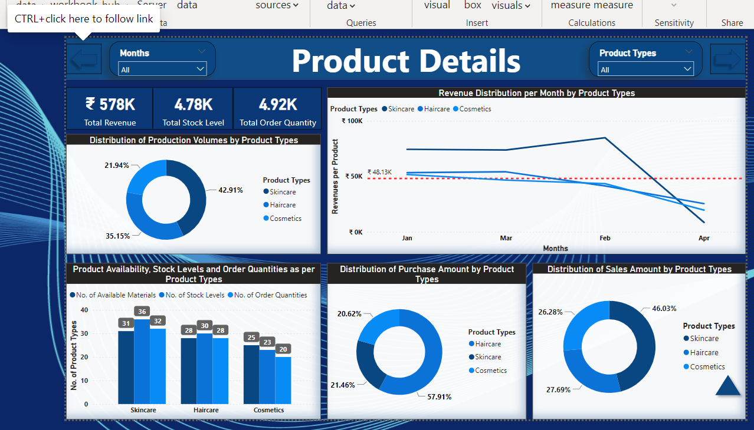

* There are three KPIsat the top left corner of the Product Details Page namely **Total Revenue, Total Stock Level, Total Order Quantity**.
* Understand different product types, their availability, and stock levels. Based on that, their order quantities too. These parameters help us to figure out the current inventory level and based on customer demand it will put necessary order quantities.
* Understand the distribution of purchase amounts for different product types and, after selling, their revenue distribution. Ordering, shipping, manufacturing, transportation, and selling amounts calculations are very crucial to calculate Revenue.
* By clicking on the “**ARROW**” on the top left and right corner of the heading, user can navigate through different pages.

**Purchase Details:**

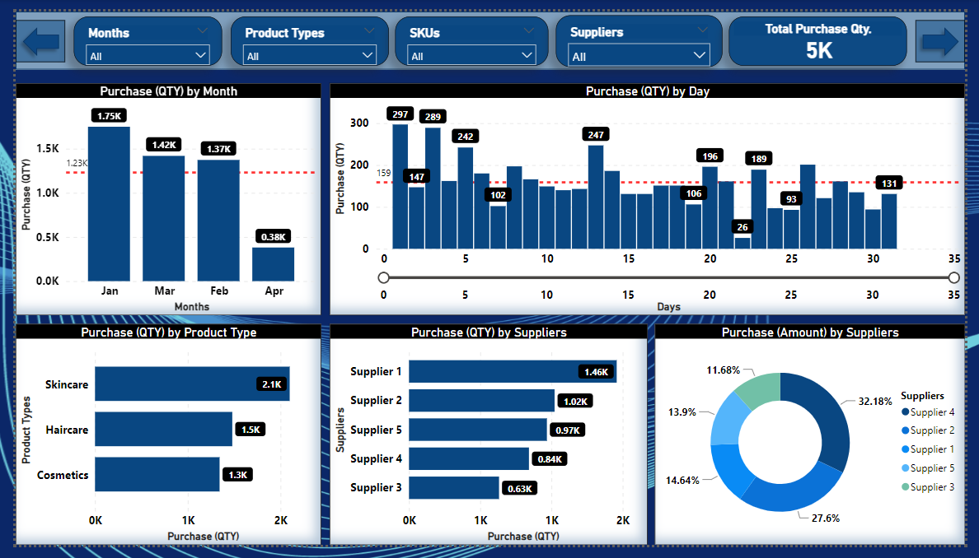

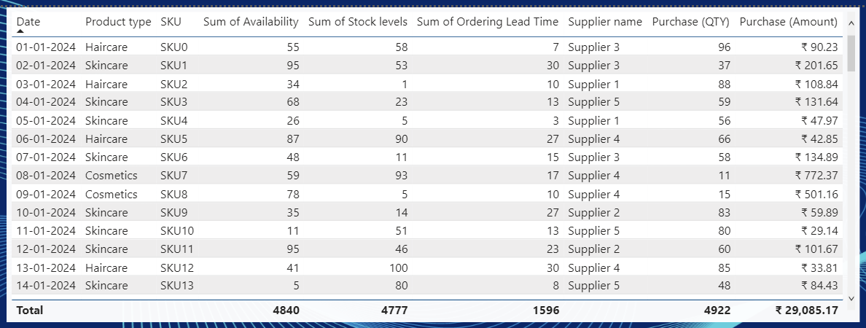

* There are four key filters at the top of the Product Details Page namely **Months, Product Types, SKUs, Suppliers.**
* There is one important KPI: **Total Purchase Qty.**
* Distribution of Product Purchase Quantity on a Daily, and Monthly basis, understand the Purchase Quantity per Product Type, these parameters help to find out which product is greatly necessary over a period. It will help to easily manage necessary resources.

**Shipping Details:**

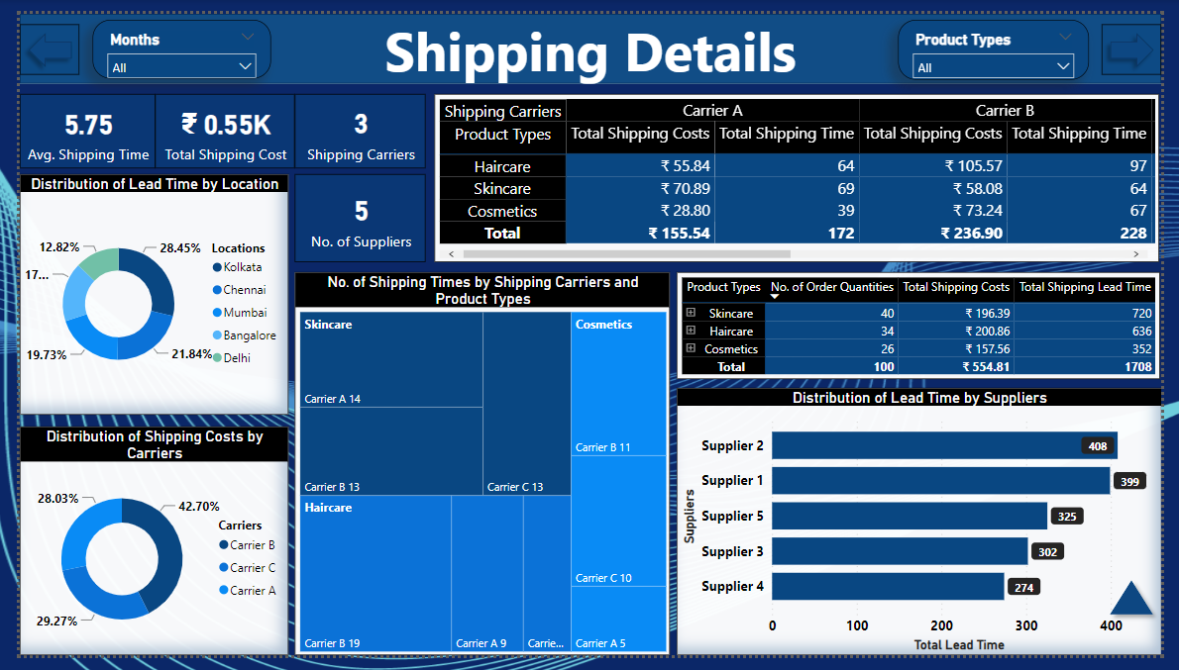

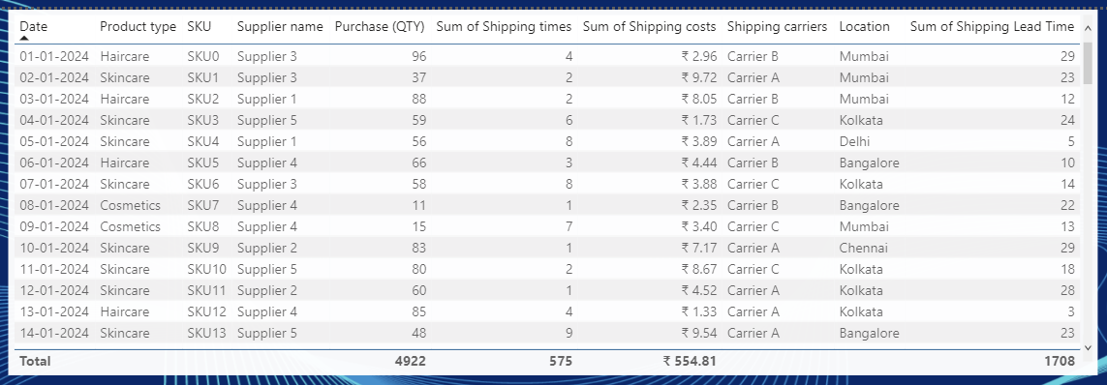

* There are four KPIs at the top left corner of the Shipping Details Page namely **Avg. Shipping Time, Total Shipping Cost, No. Of Shipping Careers, No. Of Suppliers**.
* Understanding the Shipping Costs, Lead Times, and Delivery Quantities of the Raw Materials are important to carefully shift these to the Suppliers. Basically, these are for the manufacturing of the actual goods.
* Identifying the optimized routes for shipping these goods at proper time will lead to start manufacturing of actual goods.

**Manufacturing Details:**

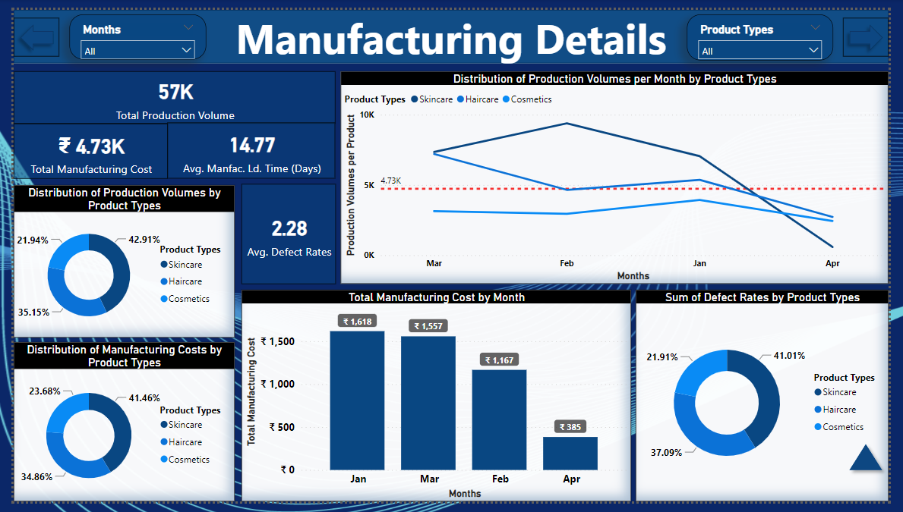

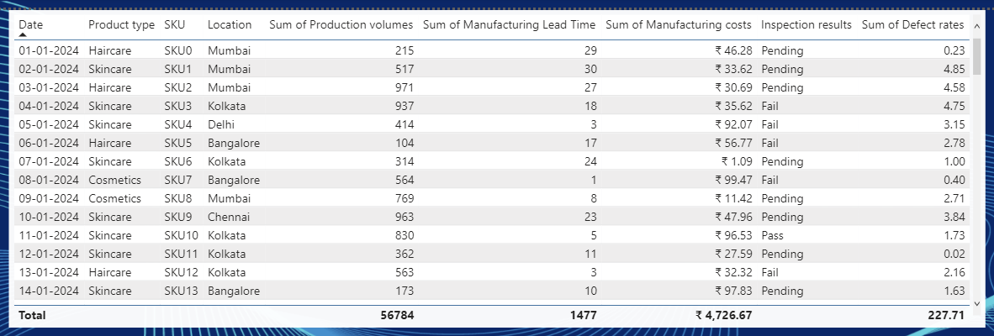

* There are four KPIs at the top left corner of the Manufacturing Details Page namely **Total Production Volume, Total Manufacturing Cost, Avg. Manufacturing Lead Time, Avg. Defect Rates.**
* Understanding the distribution of Production Volumes for different Products is also crucial. It will identify the factories' capacity to deliver quality goods.
* Defect Rates are checked through Inspections of these goods.

**Transportation Details:**

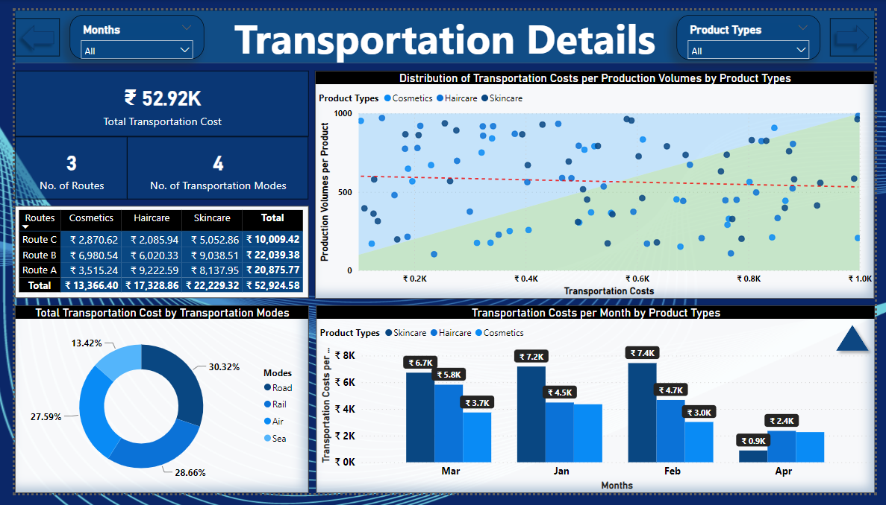

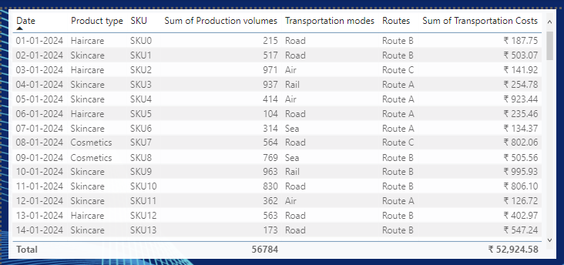

* There are three KPIs at the top left corner of the Transportation Details Page namely **Total Transportation Cost, No. Of Routes, No. Of Transportation Modes.**
* Now these finalized goods are ready to go to the market. So, understanding different Transportation Costs for different Products can minimize the respective costs based on routes and other factors.

**Sales Details:**

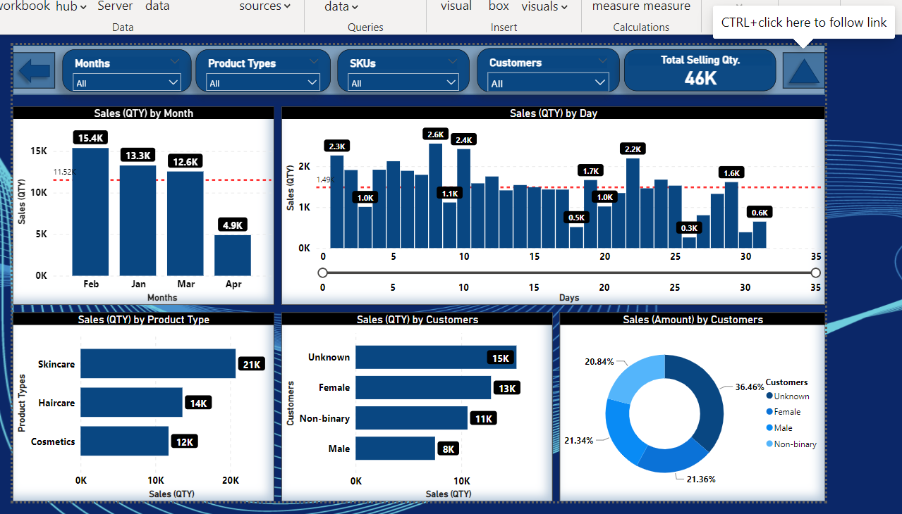

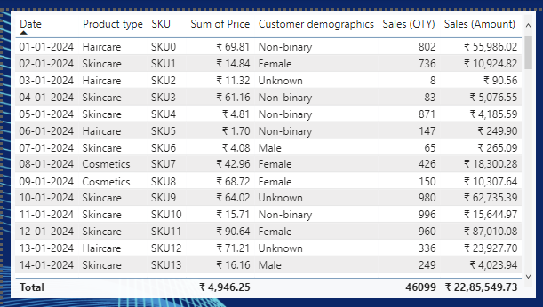

* There are four key filters at the top of the Sales Details Page namely **Months, Product Types, SKUs, Customers.**
* There is one important KPI: **Total Selling Qty.**
* Distribution of Final Products, their selling quantities on a Daily, and Monthly basis should be monitored and maintained properly.
* Understanding the Selling Quantities per Product Type is also important. This will help to identify which products are greatly accepted by the customers. Also leads to maximizing sales and boosting profit.
* Increasing sales will directly link to Revenue generation of the company.
* By clicking on the “**TRIANGLE**” on the top right corner of the heading, user can directly go to the Home Page.

**Information Section:**

The Information Section includes details like Supply Chain Report Main Page, KPI Details, and Granularity.

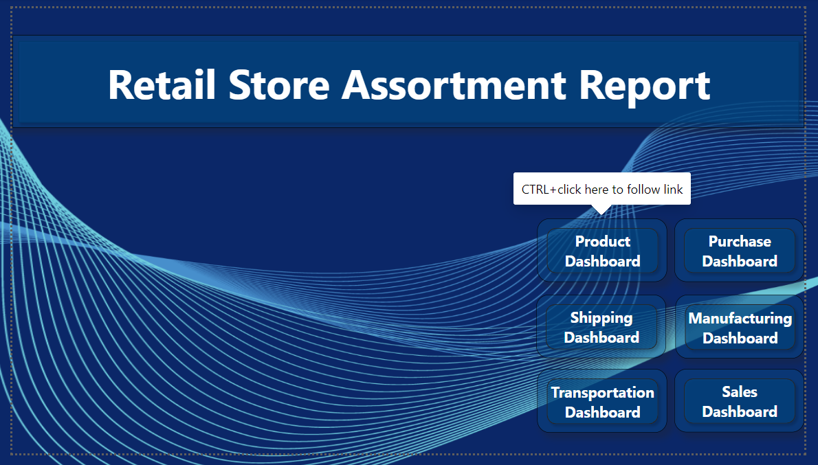

* In the Supply Chain Report Main Page all the shortcuts of different Dashboards are mentioned. Clicking “**CTRL + Specific Dashboard**” will lead to that Dashboard.

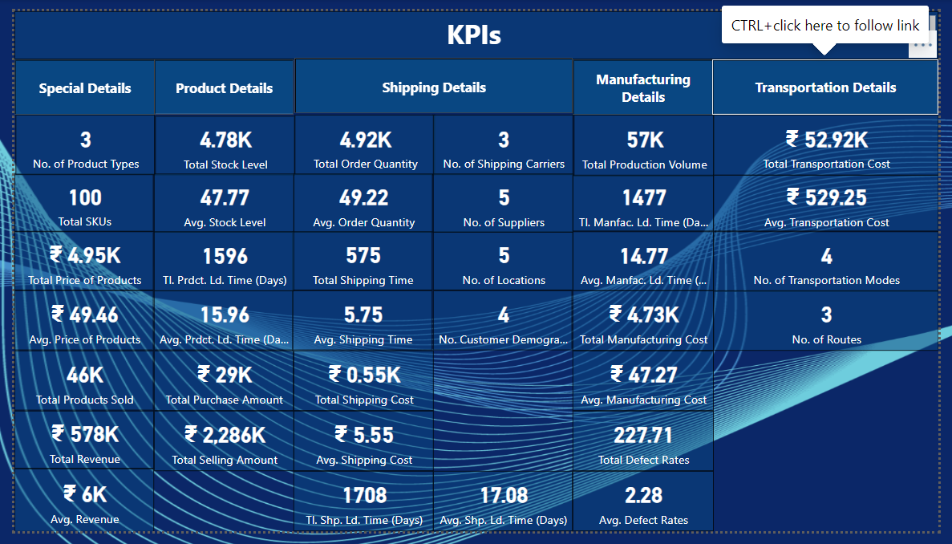

* Here all the possible along with important KPIs are mentioned. Also, by clicking the different “**Details Boxes**” users can go directly to the respective dashboards.

Granularity checks the Level of Detail in a Dataset. How the data elements are well distributed. Leads to precision of the data. Here different products have different SKUs. Each product has a unique SKU based on location.